Register Number:
DATE:

ST.JOSEPH’S COLLEGE (AUTONOMOUS), BANGALORE-27
B.Sc ELECTRONICS – III SEMESTER
SEMESTER EXAMINATION: OCTOBER 2021
(Examination conducted in February-March 2022)
EL 318 - Digital Electronics

Time- 2 ½ Hrs Max Marks-70

This paper contains 2 printed pages and 3 parts

PART-A
Answer any FIVE questions. 5 × 8 = 40

1 a) What is radix? Explain how BCD addition is performed on two numbers.
b) Explain the gray and EXCESS-3 digital codes with examples. (4+4)
2 a) Draw the circuit diagram of a two input NOR gate using diodes, transistor and
resistors. Explain its operation with truth table.
b) State and Prove De Morgan’s theorem using truth table. (4+4)
3 a) Give the steps involved for the expansion of Boolean expression in SOP form to the
standard SOP form.
b) Draw and explain a typical transfer characteristics of a CMOS inverter. Also discuss
its improvement over TTL device. (2+6)
4 a) Draw the circuit of TTL NAND gate with totem pole output and explain its working.
b) Explain the current sourcing and sinking with respect to TTL NAND gate with relevant
circuits. (4+4)
5 a) What is Demultiplexer? Draw the logic diagram of a 1-to-4-line Demultiplexer and
explain its operation.
b) Draw the logic circuit of 4-bit magnitude comparator for equality condition and explain.
(4+4)
6 a) What is an encoder? Draw the logic diagram of a decimal to BCD encoder and write
its truth table. What is priority encoder?
b) Write the logic diagram of a BCD to SEVEN segment decoder using IC 7476, along
with the functional table. (4+4)
7 a) Explain the working of a JK flip flop with a necessary circuit. What is race around
Condition?
b) What are synchronous inputs? Explain the asynchronous inputs of a flip flop with a
truth table. (4+4)

PART-B
Answer any FIVE questions. 5 × 4 = 20

8 a) Convert the OCTAL number 463 into binary and then to HEXA decimal.
b) Add the decimal numbers 25 and 13 in 8421 code. (2+2)
9 Expand the following SOP expression to minterm and maxterm.

10 A truth table has LOW outputs for inputs (ABCD) of 0000 to 0110, a HIGH output for
0111, a LOW output for 1000 to 1001 and don’t care for 1010 to 1111. Show the
simple logic circuit for the truth table.

11 a) Determine the fan-out when 74XX drives 74LSXX. (2+2)

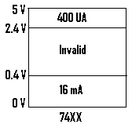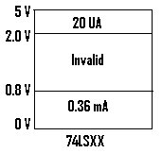
b) The propagation delay time for a gate is 10 ns and power dissipation of 2mW. If 6 such
gates are connected what is the total time delay and power dissipation of the circuit.
12 What will be the outputs at Y and Y₀, Y₁, Y₂ andY_{3.}

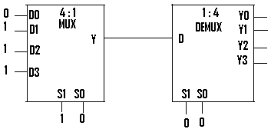
13 Draw the circuit for a serial in- parallel out shift register and explain its working for a
given data=1011.
14 Design an asynchronous decade counter. Give its truth table and draw its timing
diagram.

PART-C
Answer any FIVE questions. 5 × 2 = 10
15 Write the first 4 and last 4 negative signed numbers in 8-bit binary notation.
16 Which is the fastest logic family? What is the disadvantage of the same?
17 Write the algebraic terms of a 4-variable expression having a Maxterm M₃ and M₉ .
18 TTL devices are Compatible - Justify it.
19 Realize a full adder by using one XOR gate, one OR gate and one AND gate.
20 Mention how RS flip flop can be converted to D flip flop.
21 Distinguish between Johnson and Ring counter.
-------------------------------------------------------------END---------------------------------------------------

