16-04-2018
ST.JOSEPH’S COLLEGE (AUTONOMOUS), BANGALORE-27
B.Sc. Electronics : IV SEMESTER
SEMESTER EXAMINATION-APRIL 2018
EL412 : Electronic Instrumentation and Verilog
Time :3 Hrs Maximum marks:100
(For supplementary candidates)
Do not write the register number on the question paper
Please attach the question paper along with the answer script.

This question paper contains three printed pages and three parts
Part-A
Answer any five of the following. 5 x 12 = 60
- a) Define and classify transducers (4)
b) Explain the working and application of LVDT (4)
c) Explain the working of a pressure transducer using capacitive sensor (4)

- a) Explain the construction, working and characteristic of a photovoltaic cell. (6)
b) With a circuit diagram, explain basic integrator and derive expression for its output. Draw the frequency response of basic integrator. (6)

- a) Draw the circuit of a logarithmic amplifier and derive expression for its output.
Mention one application of logarithmic amplifier. (6)
b) Draw the block diagram of a 3-bit flash ADC and explain its working. (6)

- Explain bottom-up design methodology using a 4-bit parallel adder as an example(gate level modeling).
- Use dataflow modeling to design 4x1 multiplexer. Write its test module with following input and draw the output waveform.
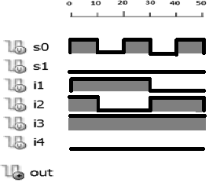 EL-412-B-15
- Use Behavioral modeling to design a down counter also write a test fixture with expected timing diagram and explain all the procedural statements used.
- With block diagram explain working of CRO and also how dual slope can be achieved

Part-B

Answer any five of the following. 5 x 6 =30

- An earth satellite has 12V batteries that supply a continuous current of 0.5A each. Solar cells used to charge the battery has the following specifications. Maximum output power at light intensity of 125 mW/cm² is operated at V₀ = 0.45 v and I₀ = 57mA. Assuming the average light intensity is 125 mW/cm² and average time of illumination is 12 Hrs/day, calculate the number of solar cells requires to keep the battery charged.
- Design a D.C. voltmeter of range 1-10V using an op-amp V to I converter and a milliammeter of current sensitivity 0.1 mA/division and of 10 divisions.

- Design a differentiator that will differentiate an input signal with f_{max} = 100 Hz.

- Design a R and 2R three bit D/A convertor with Op-amp and a voltmeter of 10 V FSD.
- With necessary diagrams and equations explain the working of a Digital Voltmeter that uses a dual slope integrator to do the analog to digital conversion.
- Write a module to represent the following RTL design and also write the test fixture and draw the output waveform for the following input.
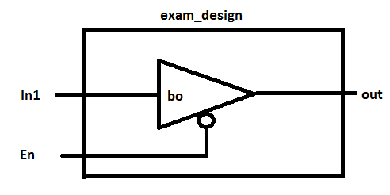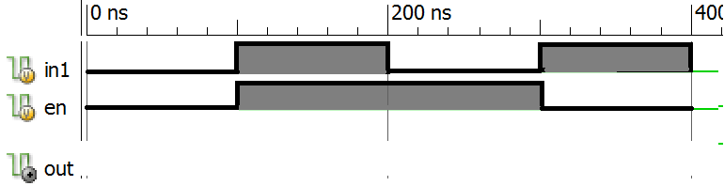

- Explain sequential and parallel blocks in verilog HDL with examples.

Part-C

Answer any five of the following. 5 x 2 = 10

- Match the following:
MUX passive transducer
LM-35 part of data acquisition system
Photodiode active transducer
Microphone temperature measurement
Signal conditioning logarithmic amplifier

- Sketch output waveform of a differentiator for a rectangular input wave.
- FSD of a voltmeter used in a 3 bit DAC is 10 V. calculate the output voltage corresponding to binary output 111
- Compare successive approximation ADC to Flash ADC.
- If A=4b'1XX1; B=4b'1XX1; C=4b'101X then what is the output logic state for the following expressions:
i. A===B ii. A!=C
- For the following diagram what is the frequency at Q1 and Q2?
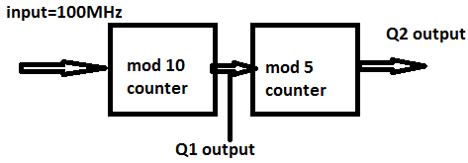
- Where is the key word ‘end’ used? Is the keyword end a must after initial/always?

_______x___________________x_______________________x___________

